**Docker**

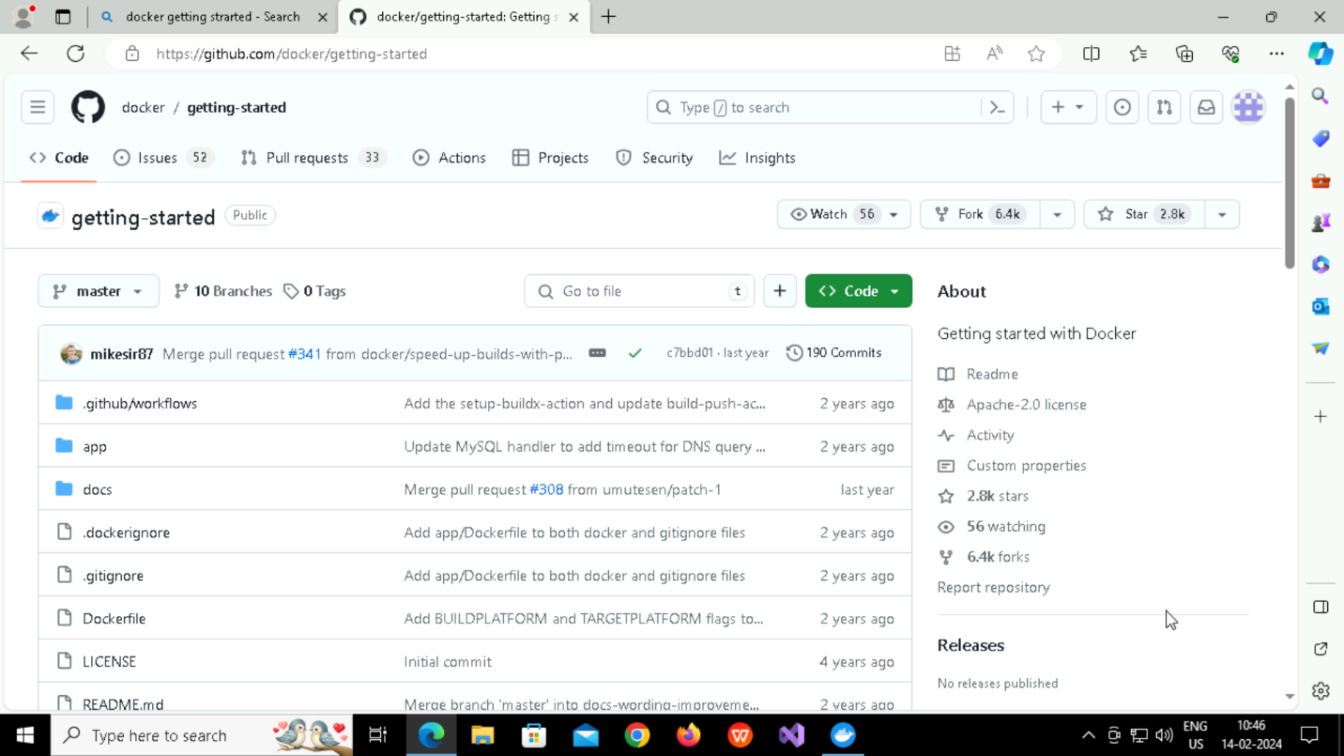

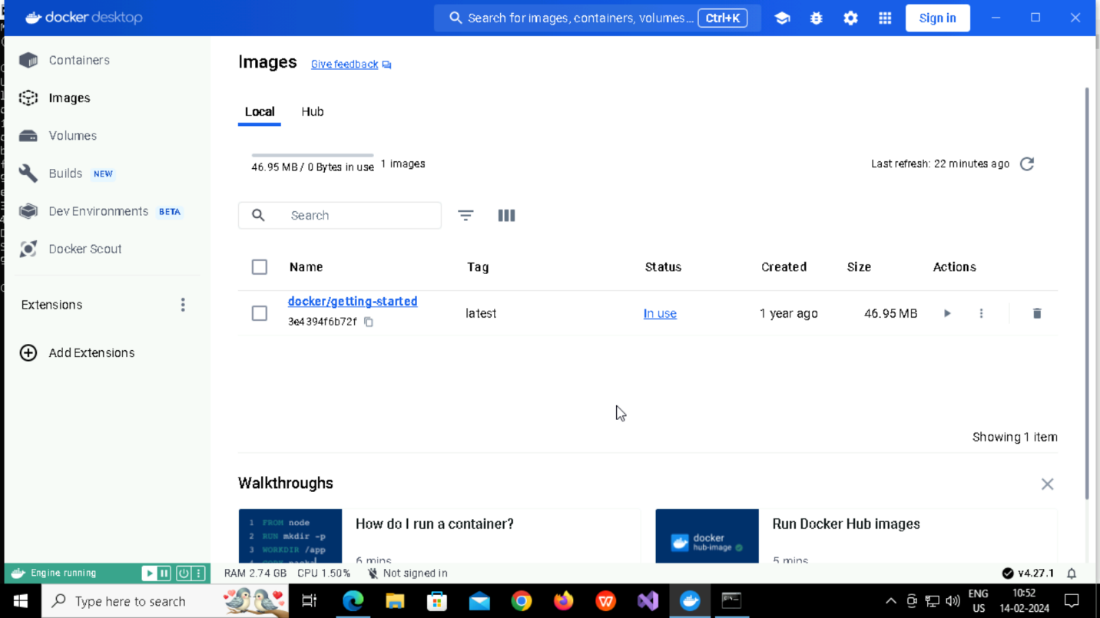

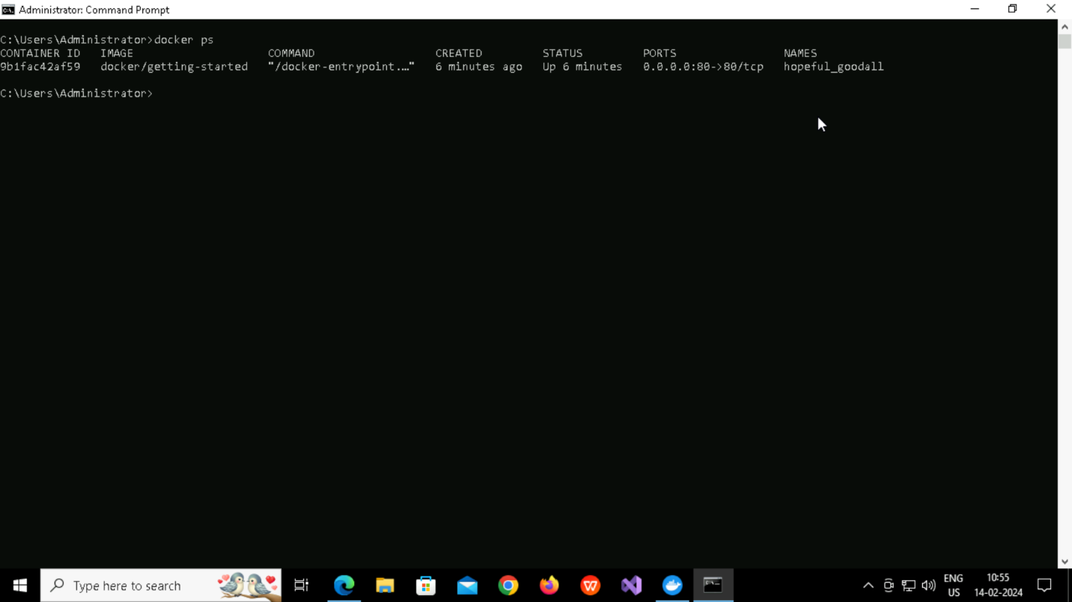

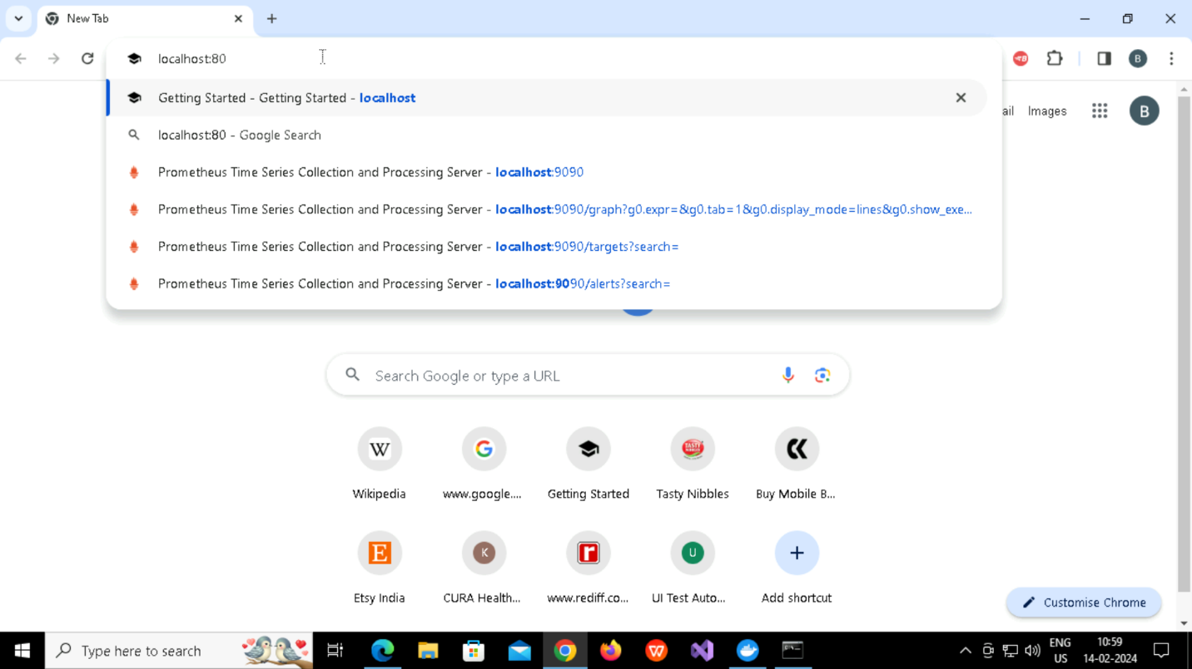

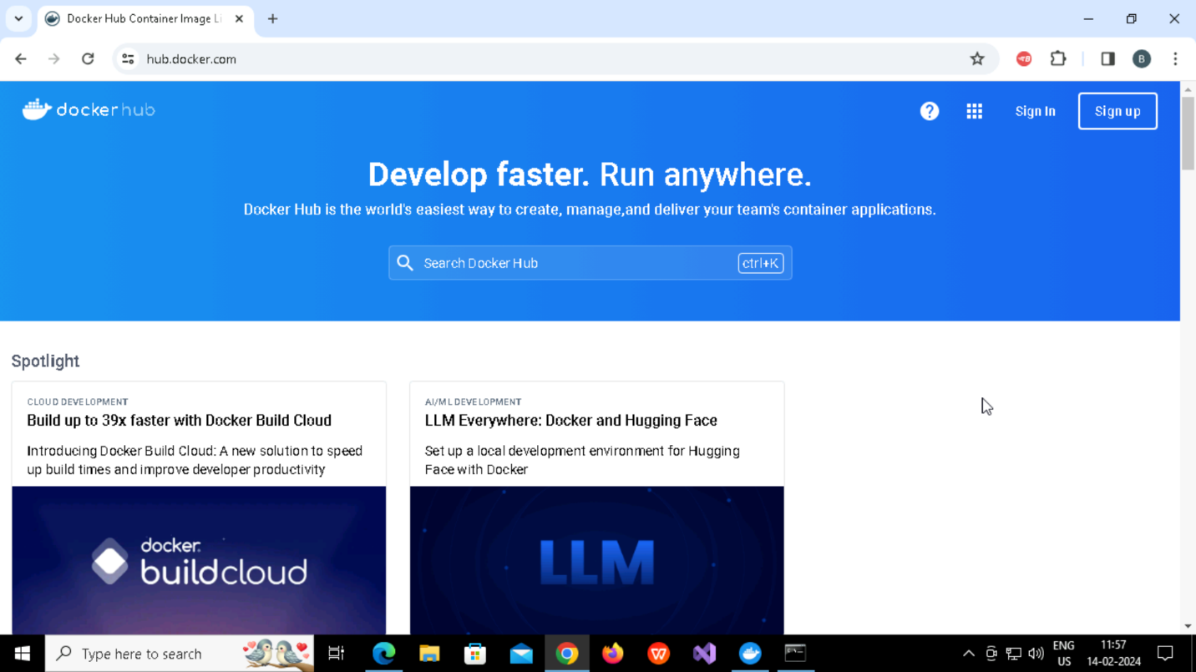

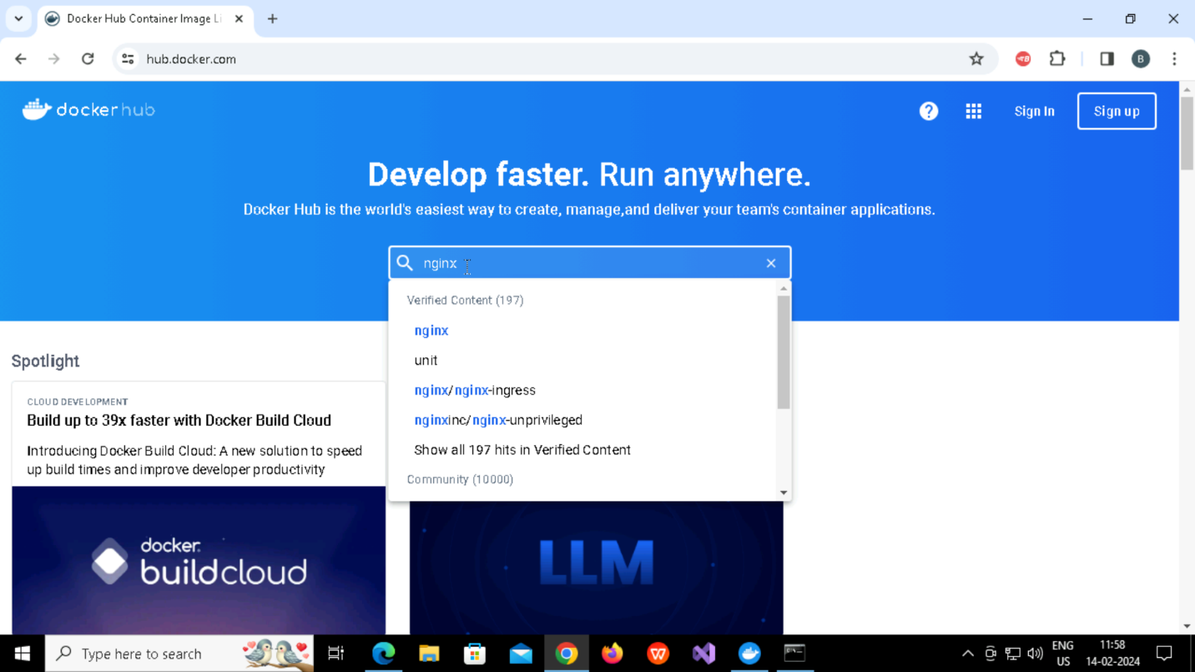

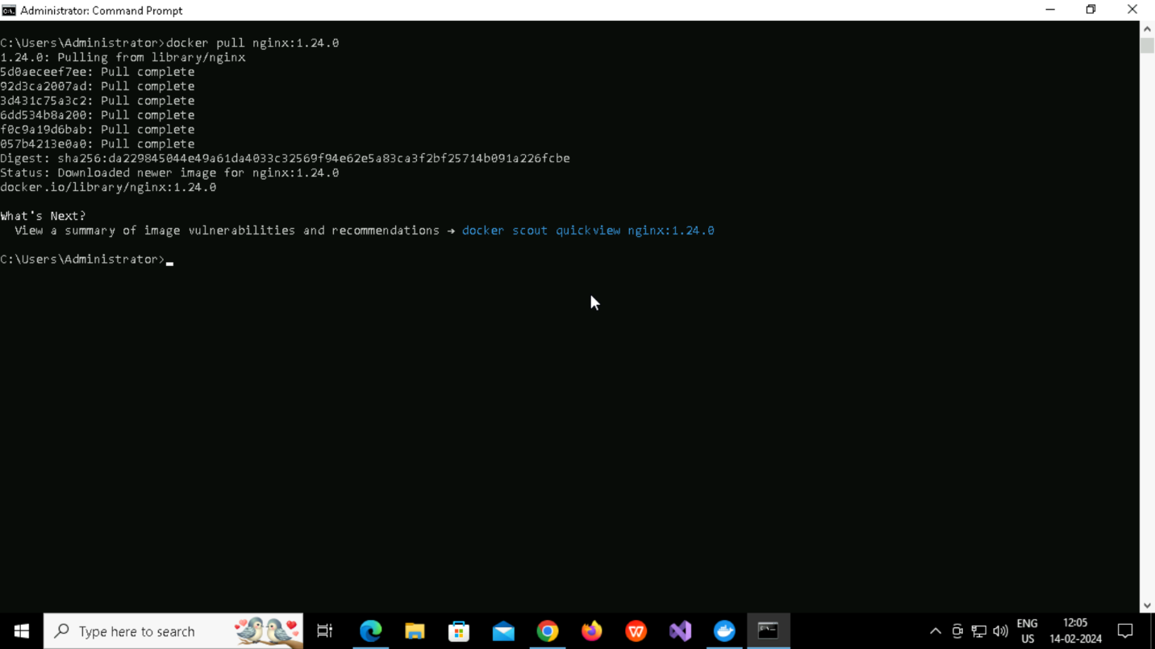

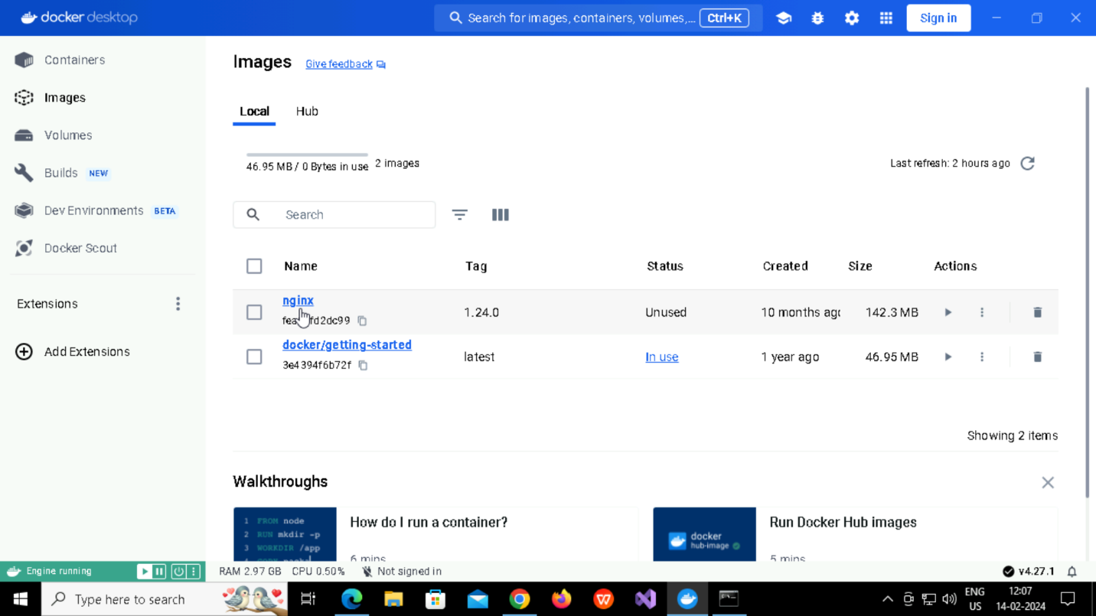

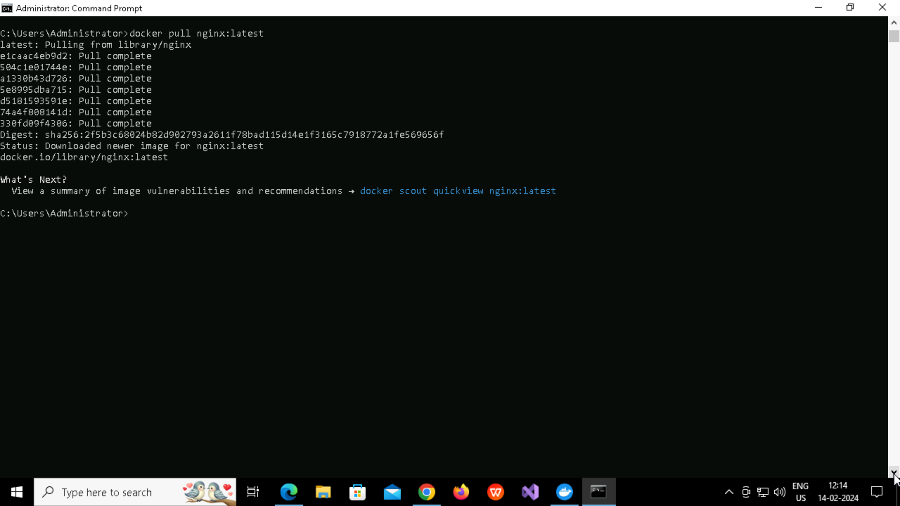

**Detach mode**

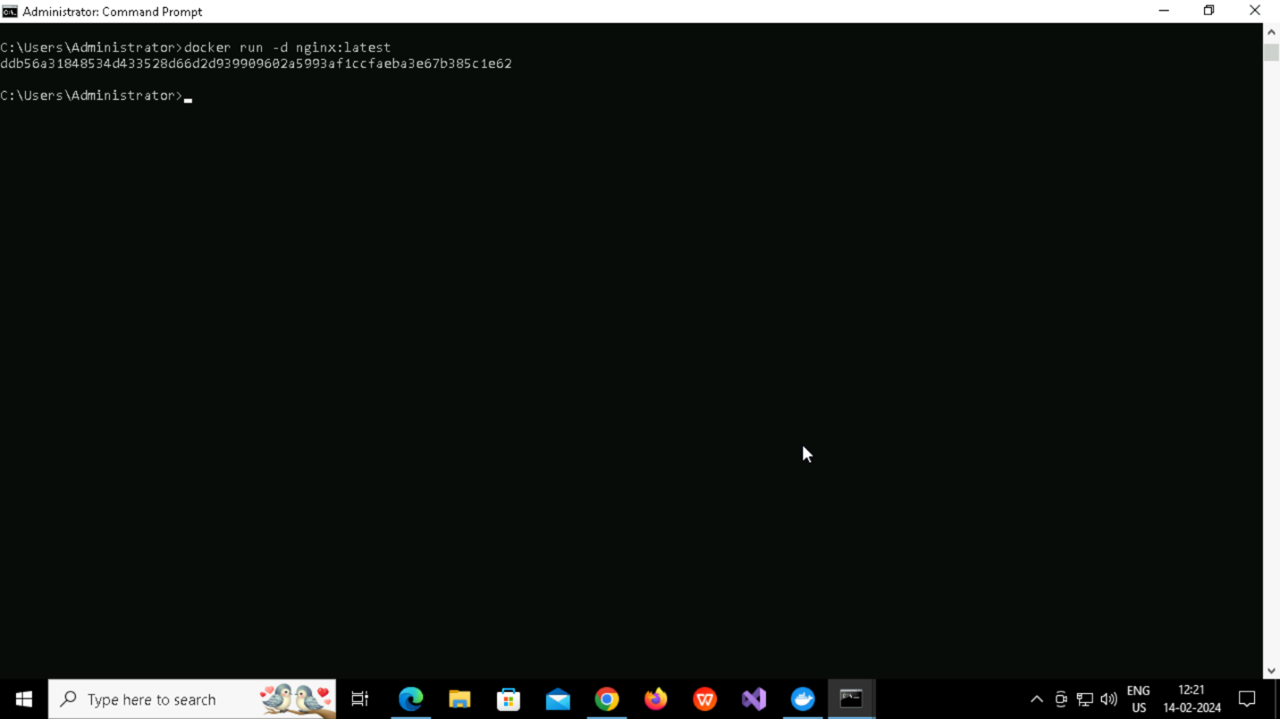

**Docker logs**

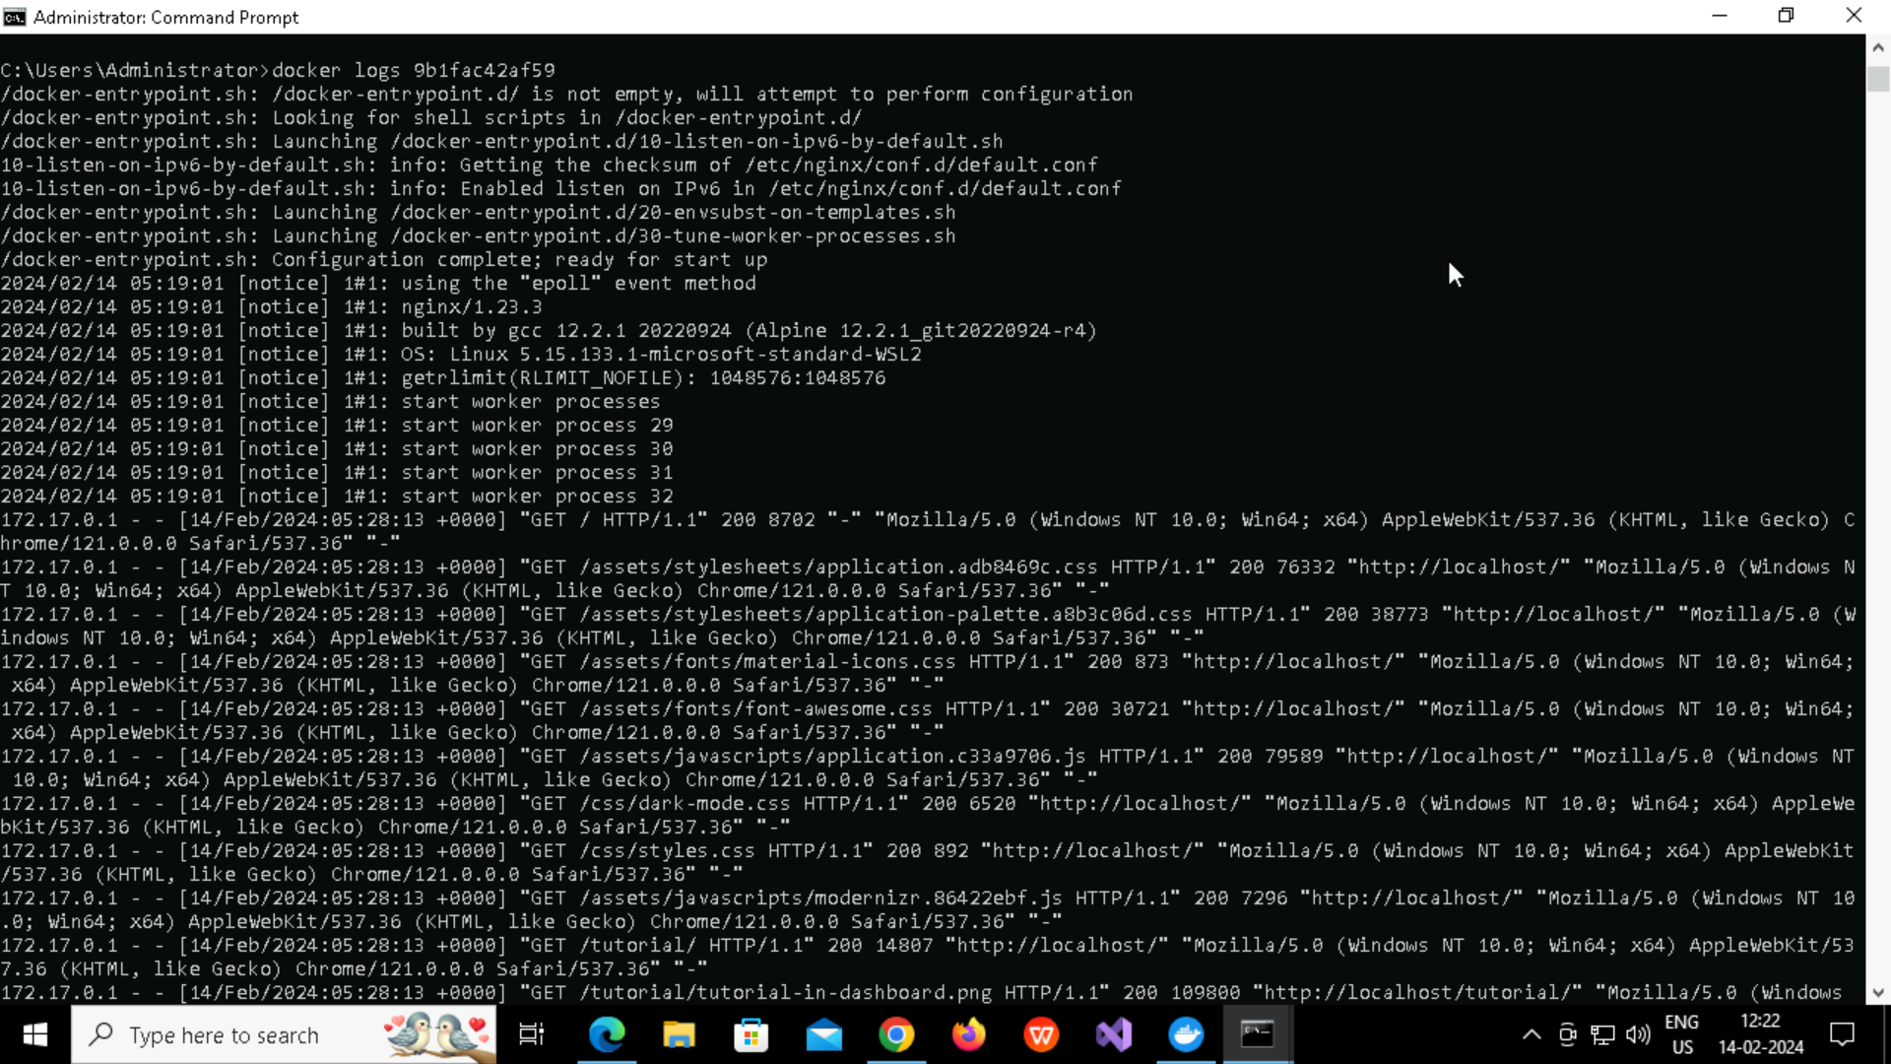

**Docker stop**

**Giving own name to container(like my_container)**

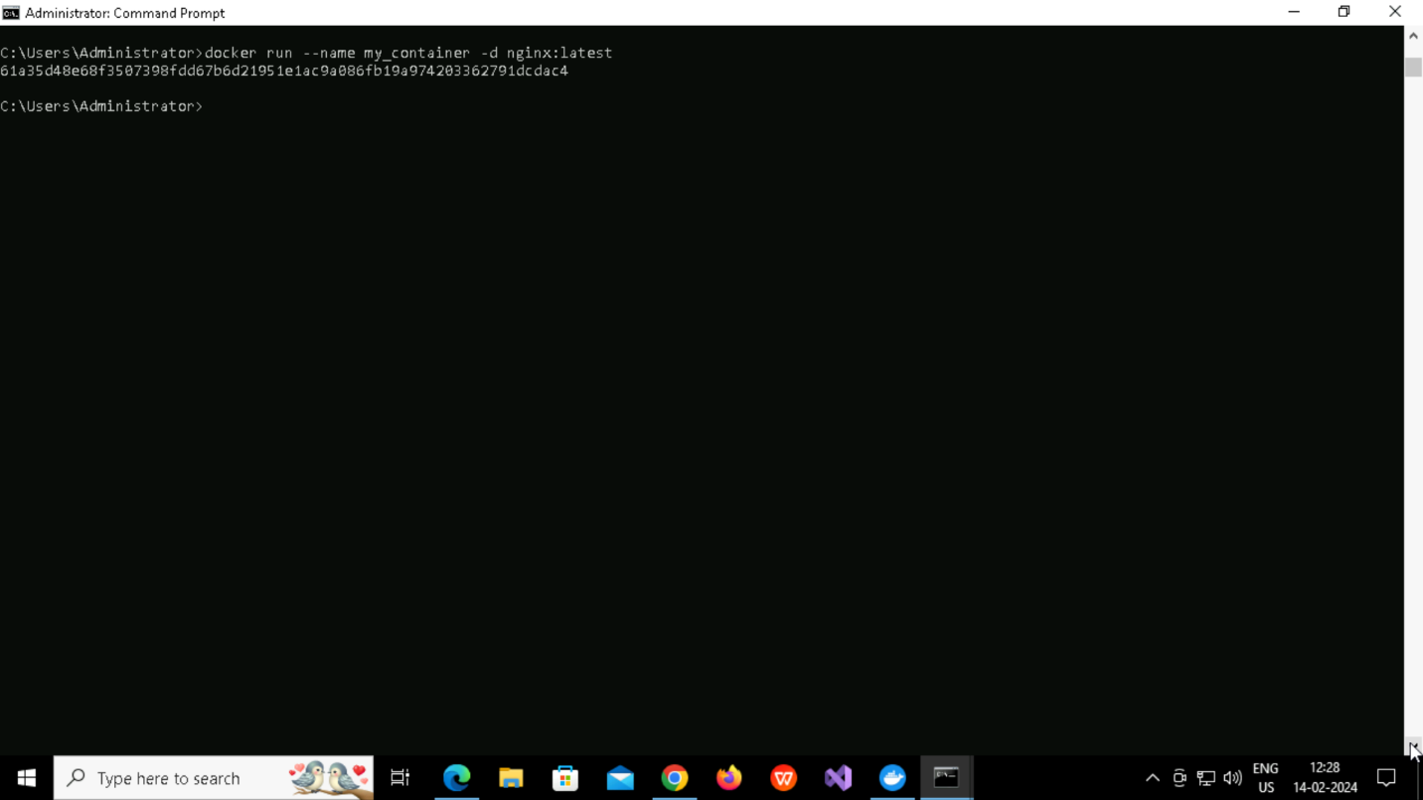

**Docker logs**

**ubuntu**

**Redis**

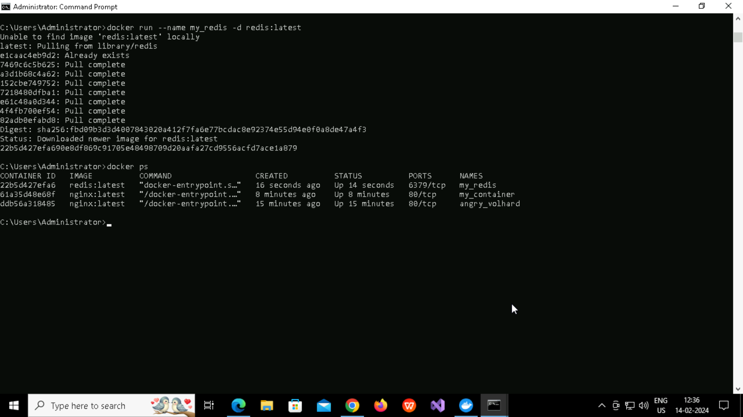

**Port Binding**

**First stop the container**



**You will be able to see ported(9090->6379)**





